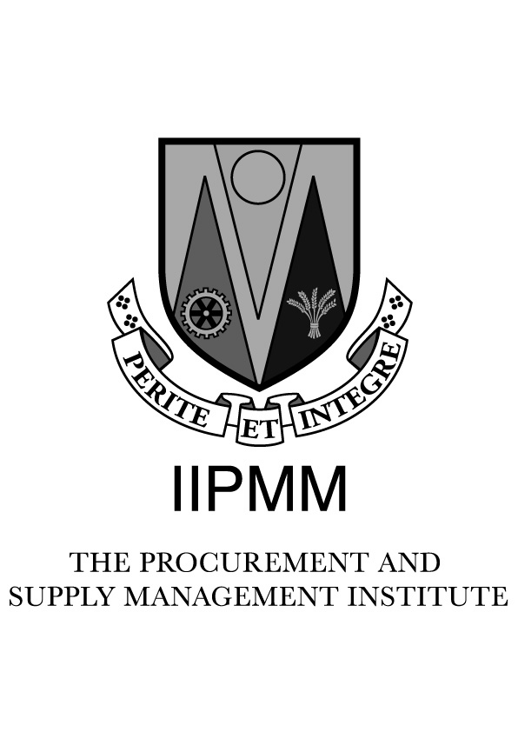

IIPMM

Bachelor of Business (Honours), Procurement and Supply Management

REGISTRATION FORM 2012/2013
- Personal Details

First Name:_________________________________ Family Name: _____________________________________

PPS Number:________________________________ Gender: Male Female
(mandatory)
Nationality: ______________________________________
Contact Details:

Phone (H): ___________________________________________

Phone (W): ___________________________________________

Email: ___________________________________________ (mandatory)

Address: ___________________________________________________________________________________

____________________________________________________________________________________

Date of Birth: ____/____/____

2. Education

Third Level:

College: _________________________________

Award: __________________________________ _________________

College: _________________________________

Award: __________________________________ _________________

Professional Qualification(s):

Professional Body: ___________________________________________________

Award: ___________________________________________

Professional Body: ____________________________________________________

Award:____________________________________

3. Employment Details

Employer: ______________________________________________________________________________________

Address: _______________________________________________________________________________________

________________________________________________________________________________________

Current Position: ________________________________________________________________________________

Main Duties/Nature of Work: ______________________________________________________________________
_______________________________________________________________________________________________

Commencement date: ____/____/____

Your experience in supply management (to the nearest year): _________ Years

Previous Employment History starting with your current role (you may continue on a separate sheet):

Date: ____/____/____ Company: ________________________ Position: _____________________________

Date: ____/____/____ Company: ________________________ Position: _____________________________

Date: ____/____/____ Company: ________________________ Position: _____________________________

Recommendation by current employer:

I recommend this applicant as a student to the Institute and our organisation will provide the necessary support and mentoring to facilitate their development as a procurement professional. The company signatory must be a senior member of the management team, preferably your line manager.

Signed: ______________________________________ Position:_____________________________________

Dated: ____/____/____

- Modules to be taken

Level 8
Business Policy Bridging Studies :

Advanced Supply Management Marketing & Bus Comm. (both)

Strategic Procurement Commercial Relationships (Diploma only)

Research Assignment Economics (Graduateship only)

Study methodology

Block Learning Only:

UCD Dublin UCC Cork

Examinations will be held in May 2013, see academic calendar for dates etc.

Examination Centre; Dublin Cork

Alternative _________________
(Venue availability will be subject to numbers)

6. Fees

The prices indicated here are only available where 50 % deposit is paid before the 31st of May 2012 and the balance is paid by 31st August 2012.

Fee Payment

Modules: Bridging Studies*:
Business Policy @€975 ______

Advanced Supply Management @€975______ Marketing & Bus Comm. @€250 (Both) ______

Strategic Procurement @€975 ______ Commercial Relationships @€250 (Dip. only) ______

Research Assignment @€675 ______ Economics @€250(Grad. only) ______

Totals € _____ €_____

Overall Total €_____

All fees include registration fees, course materials, on-line resources, revision courses, tutor fees and, examination fees. All fees are payable directly to the IIPMM.

Payment Method

a). Credit Card / Laser

Laser Mastercard Visa

Card Number: ________________________________________

Expiry Date: __________________

Security Number: _________ (three digit number on rear of card)

b). Cheque / Postal Order (must be included with Application) Total amt. ____________________________

NB. Access to MOODLE will be issued on receipt of full payment

*) Students will be contacted if any bridging is required.

Graduates of the Diploma in Purchasing and Materials Management
If you elected to study Marketing and Supply Chain Management there are no gaps and consequently, no bridging studies are required. However, if you did not elect to take one or both of these electives, then bridging studies will apply, unless you can demonstrate prior academic qualifications in the following modules:
Marketing and Business Communications
Commercial Relationships

Graduates of the Graduateship in Supply Chain Management
In order to qualify for entry to the Bachelor of Business (Honours), Procurement and Supply Management you will be required to complete the following Bridging Studies, consisting of 2 modules, unless you can demonstrate prior academic achievement in these areas. The two bridging modules required are:
Economics
Marketing and Business Communications

The bridging studies will comprise of 2 hours of tutorials and the submission of one assessment, per module. Venue and dates will be announced shortly.
Students can apply for the bridging modules during the academic year 2012/2013.

5. Exemptions

There are no exemptions available in the level 8, Honours Degree programme.

7. Terms and Conditions.

I hereby confirm that I have read the Syllabus and understand the nature of the programme and the commitment that I am making in respect of the education programmes of the Irish Institute of Purchasing and Materials Management.

In particular, I have read and agree to abide by the rules and regulations, as set out in the Learner Handbook and Quality Assurance Policy and Procedures which are available on the IIPMM website. In particular, I understand that cheating or personation in assessments may result in being barred from sitting any Institute assessments and that plagiarism in respect of assignments may also result in cancellation of results and being barred from taking any Institute assessments.

It is my responsibility to inform the Institute of any changes in personal circumstances including changes of address during the academic year.

It is my responsibility to ensure that I have enrolled on the appropriate tuition course for the IIPMM programme.

I agree that once accepted as a student of the Institute, I am fully liable for all fees due and that fees paid are non-refundable

This form along with the correct fee and payment details should be submitted no later than 31st August 2012.
Please note that tuition commences in September each year.

Processing of fees is not or cannot be implied to construe acceptance of any student application. Where an application is refused a full refund will be made.

Signed: ___________________________________

Dated: ____/____/____

Accepted on Programme by IIPMM Yes / No initials: ________ Date: _____/______/______

8. Checklist

All sections of application form completed.

Evidence of academic achievement enclosed (if not done previously).

Correct fee and payment details are included.

Please note that tuition commences in September each year.

